To get started with this process, you need to have the Github client downloaded and ready to go. You can obtain this by going to: <http://windows.github.com/> for windows,  <http://mac.github.com/> for mac. Once you have this, have an account, and have been added to the repo, we are then set to begin making changes to the code.

1. Start the github client. You should see a page similar to this:

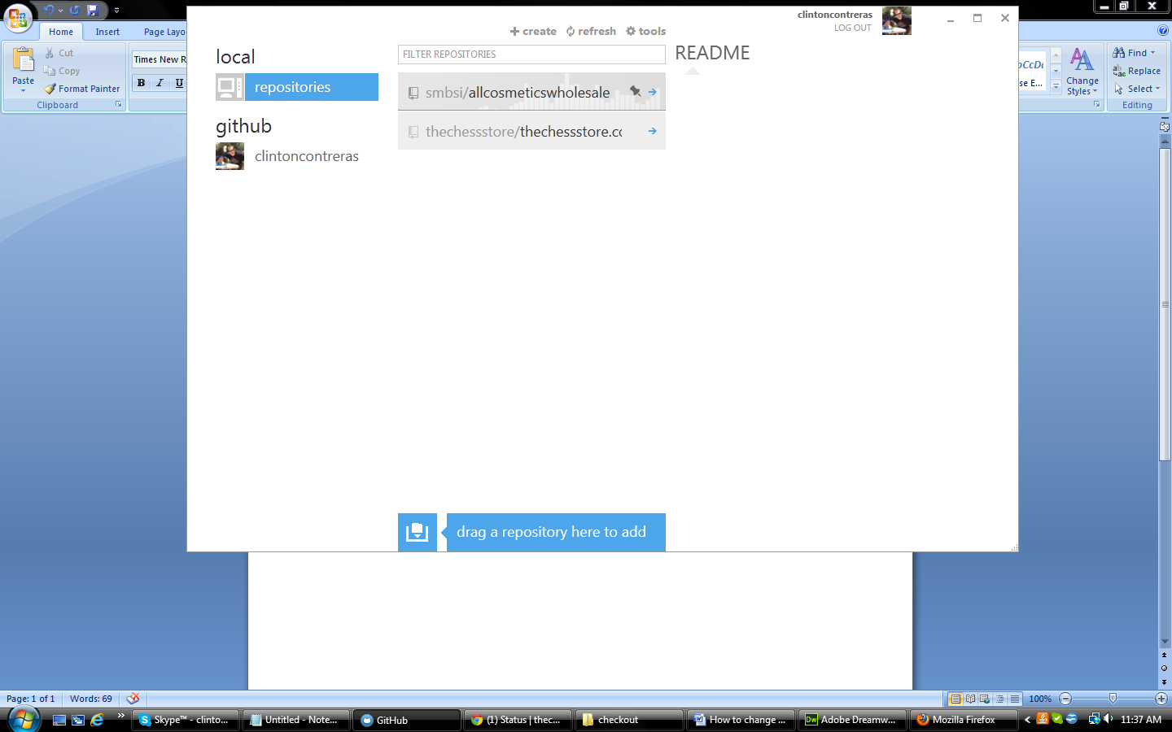

1. If you have not done so already, make a clone of the repo by navigating to the github tab on the left hand side and clicking the clone button next to the appropriate repo.
2. Click on the arrow inside of the repo to enter the repo for your project. The next screen should look like this:

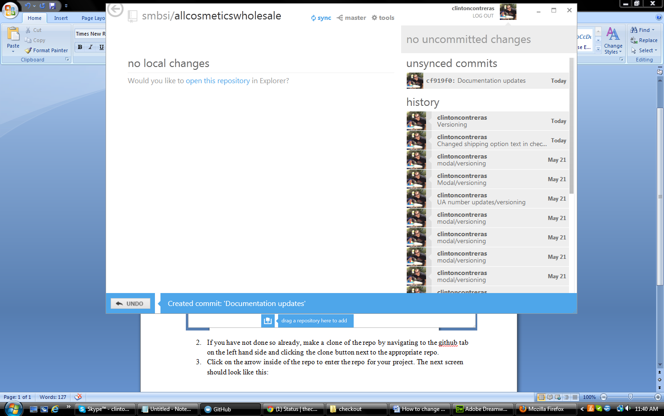

1. Once here, you should see a blue button that says sync with a blue circular arrow pattern(see above image, next to the master symbol up top). IF this is displaying, please click the icon to sync to the newest version of the project. If this blue icon is not there and it has a check mark followed by in sync, the project is up to date and ready to go.
2. Click the tools icon. A drop down should open, click the open in explorer button. Your files should open in a folder.
3. Open the html file titled: index.html. You can use any text editor of your choice, however, for coding purposes, I highly recommend using notepad++ as it makes it much easier to navigate the code as well as being free to download.
4. For the global banner (see image below), use the below steps:

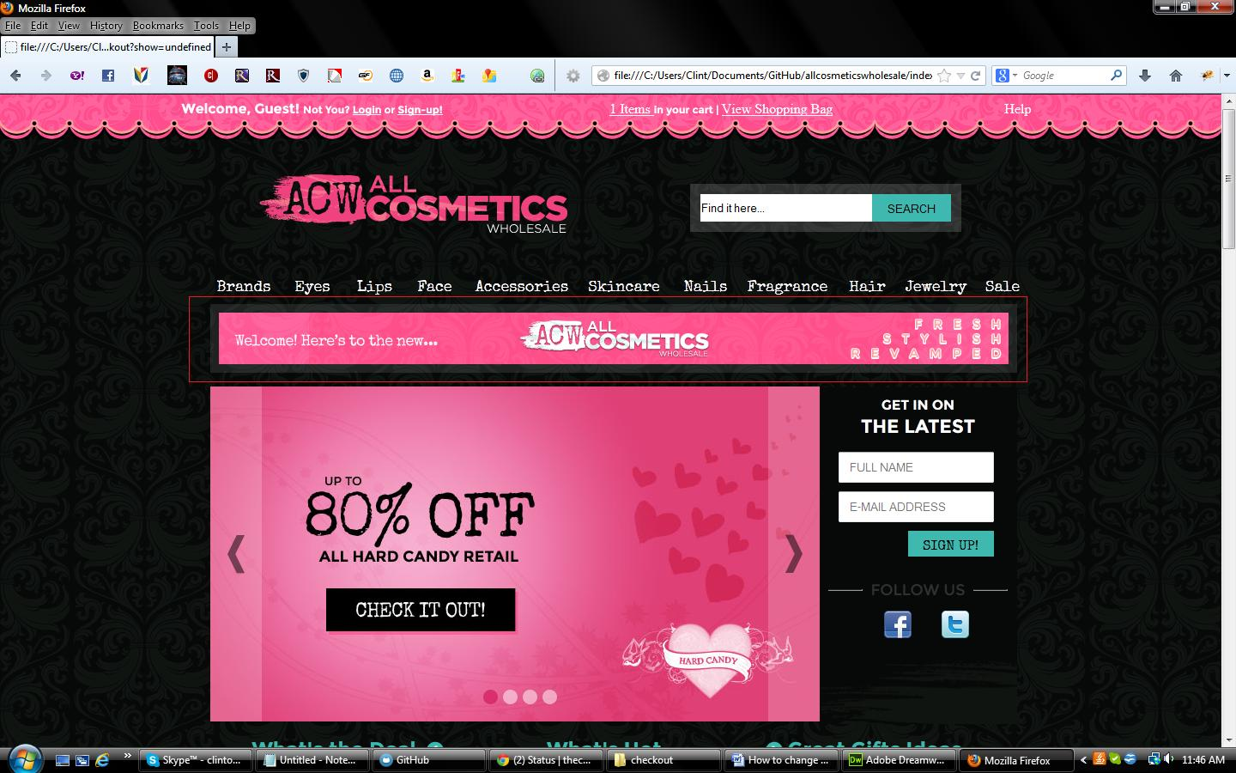

* 1. Navigate to the images folder, open the header_ad_bar folder. Add your image to this folder to make adding the image to the code that much easier.
  2. Navigate to this line: line number: 564, <img src="images/header_ad_bar/templateBanner_940x80_allCosmeticsWholesale_welcome_2.png" /> . I suggest if using a coding program of some kind, to use the line finder and input 564. As an alternative, you can use the find function (ctrl + f) and input: <div class="headerAdBar">

<img

Into it to find the line.

* 1. Once you have the line, there should a section that starts with src=” , the entry after this is the path to the image. If you followed the process in step a. , remove the entry that will look something like this: templateBanner_940x80_allCosmeticsWholesale_welcome_2.png and replace it with the name of the image you put into the folder in step a. For example, if your image is named: templateBanner_940x80_allCosmeticsWholesale_welcome_2.png , the line should look like: src="images/header_ad_bar/templateBanner_940x80_allCosmeticsWholesale_welcome_2.png" The image should now be uploaded to the site BUT not synced to the live site yet.
  2. Navigate across this line to an area that says onclick=”.
     1. For navigation to a category, enter the change the text after the . to name of the category. For example, if your category is acw.sale . the line should look like: onClick="return showContent('category',{'navcat':'.acw.sale'});"

1. For changing the images for homepage slideshow banner(see image below):



* 1. Navigate to the images folder, open the homepage folder, then the banner folder. Add your image to this folder to make adding the image to the code that much easier.
  2. Navigate to this line: line number: 822, <ul class="carouselHPBannerList">. I suggest if using a coding program of some kind, to use the line finder and input 822. As an alternative, you can use the find function (ctrl + f) and input: <ul class="carouselHPBannerList"> Into it to find the line.
  3. Once you have the line, You should see 4 or less elements that start with <li and have a another element inside of them that start with <img. If you are replacing one banner with another, locate the banner image you want to replace.
  4. If you followed the process in step a. , remove the entry that will look something like this: <img src="images/homepage/banner/templateBanner_710x390_allCosmeticsWholesale_hardCandy.jpg" /> and replace the name of the image you put into the folder in step a. For example, if your image is named: templateBanner_710x390_allCosmeticsWholesale_hardCandy.jpg , the line should look like: <img src="images/homepage/banner/templateBanner_710x390_allCosmeticsWholesale_hardCandy.jpg" /> The image should now be uploaded to the site BUT not synced to the live site yet.
     1. Navigate across this line to an area that says <li class="pointer" onClick="
     2. For navigation to a category, enter the change the text after the . to name of the category. For example, if your category is acw.brands.hard_candy . the line should look like: onClick="return showContent('category',{'navcat':'.acw.brands.hard_candy'});"

1. Once you have made the changes you want , SAVE it immediately.
2. Go back over to the github client, You should see something that looks like this:

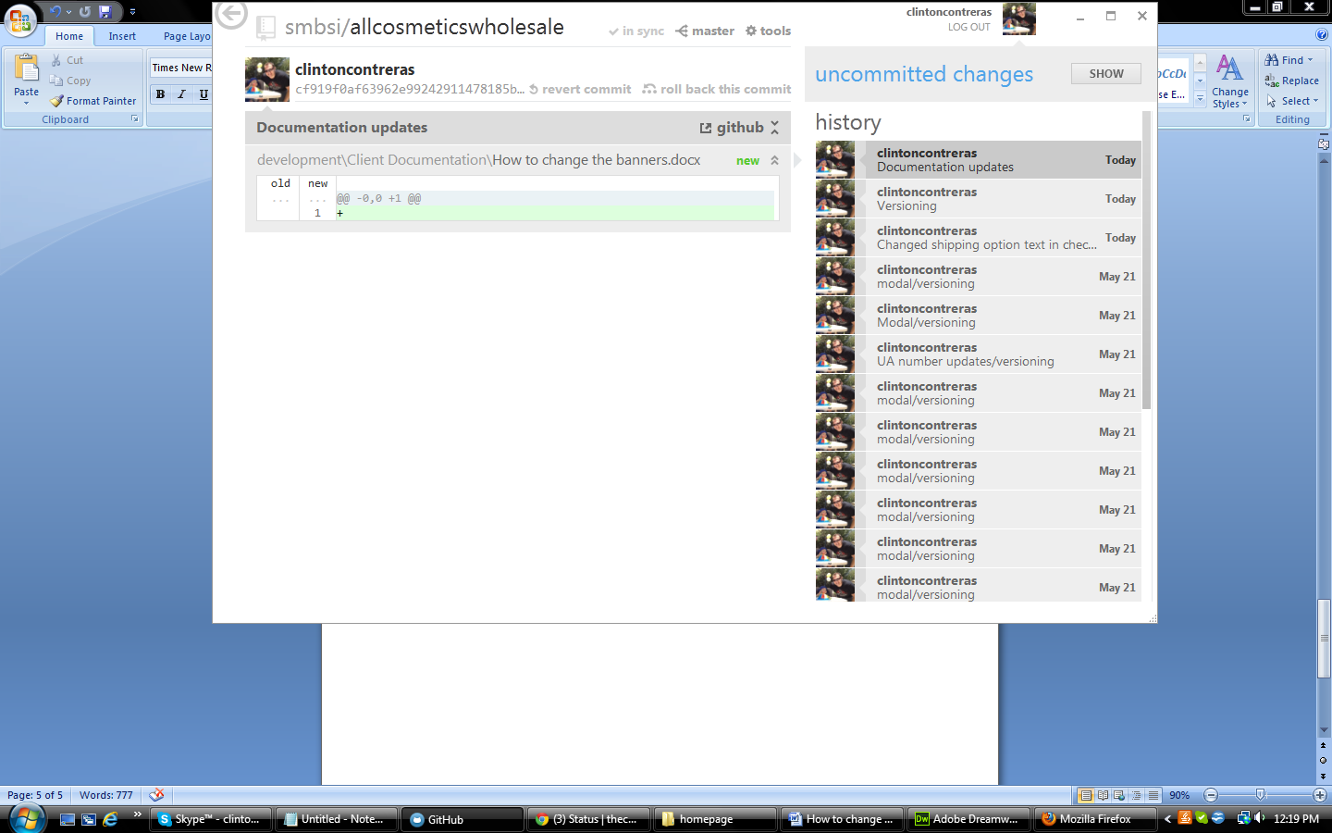

1. Click the show button next to the uncommitted changes.
2. You should now see a box that lets you input a name for your changes. Go ahead and enter the details and click the commit button.
3. Once your commit is labeled and good to go, you will notice your checkmark, in sync button has converted to the blue sync button. Click to sync your work.
4. Once the sync is completed, your changes should be updated and running live. HOWEVER, once in awhile, the auto webhook does not grab the changes from github in a timely manner so to manually activate the webhook, you can manually hit it by going to the webhook in podio and hit the link titled webhook.
5. Your changes should be live now. If they are not, contact ZOOVY to so we can find out why your changes are not being put up live.